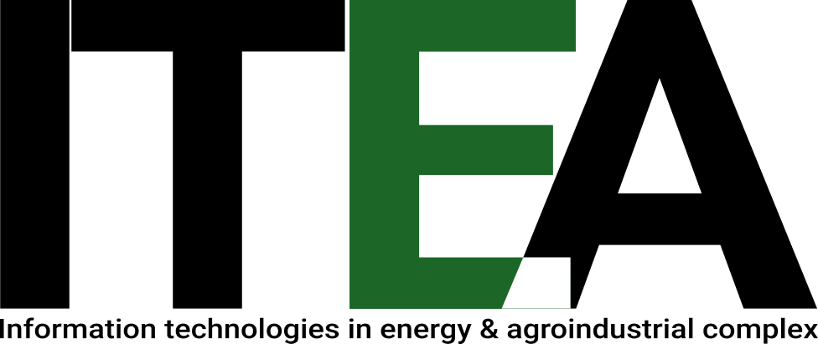
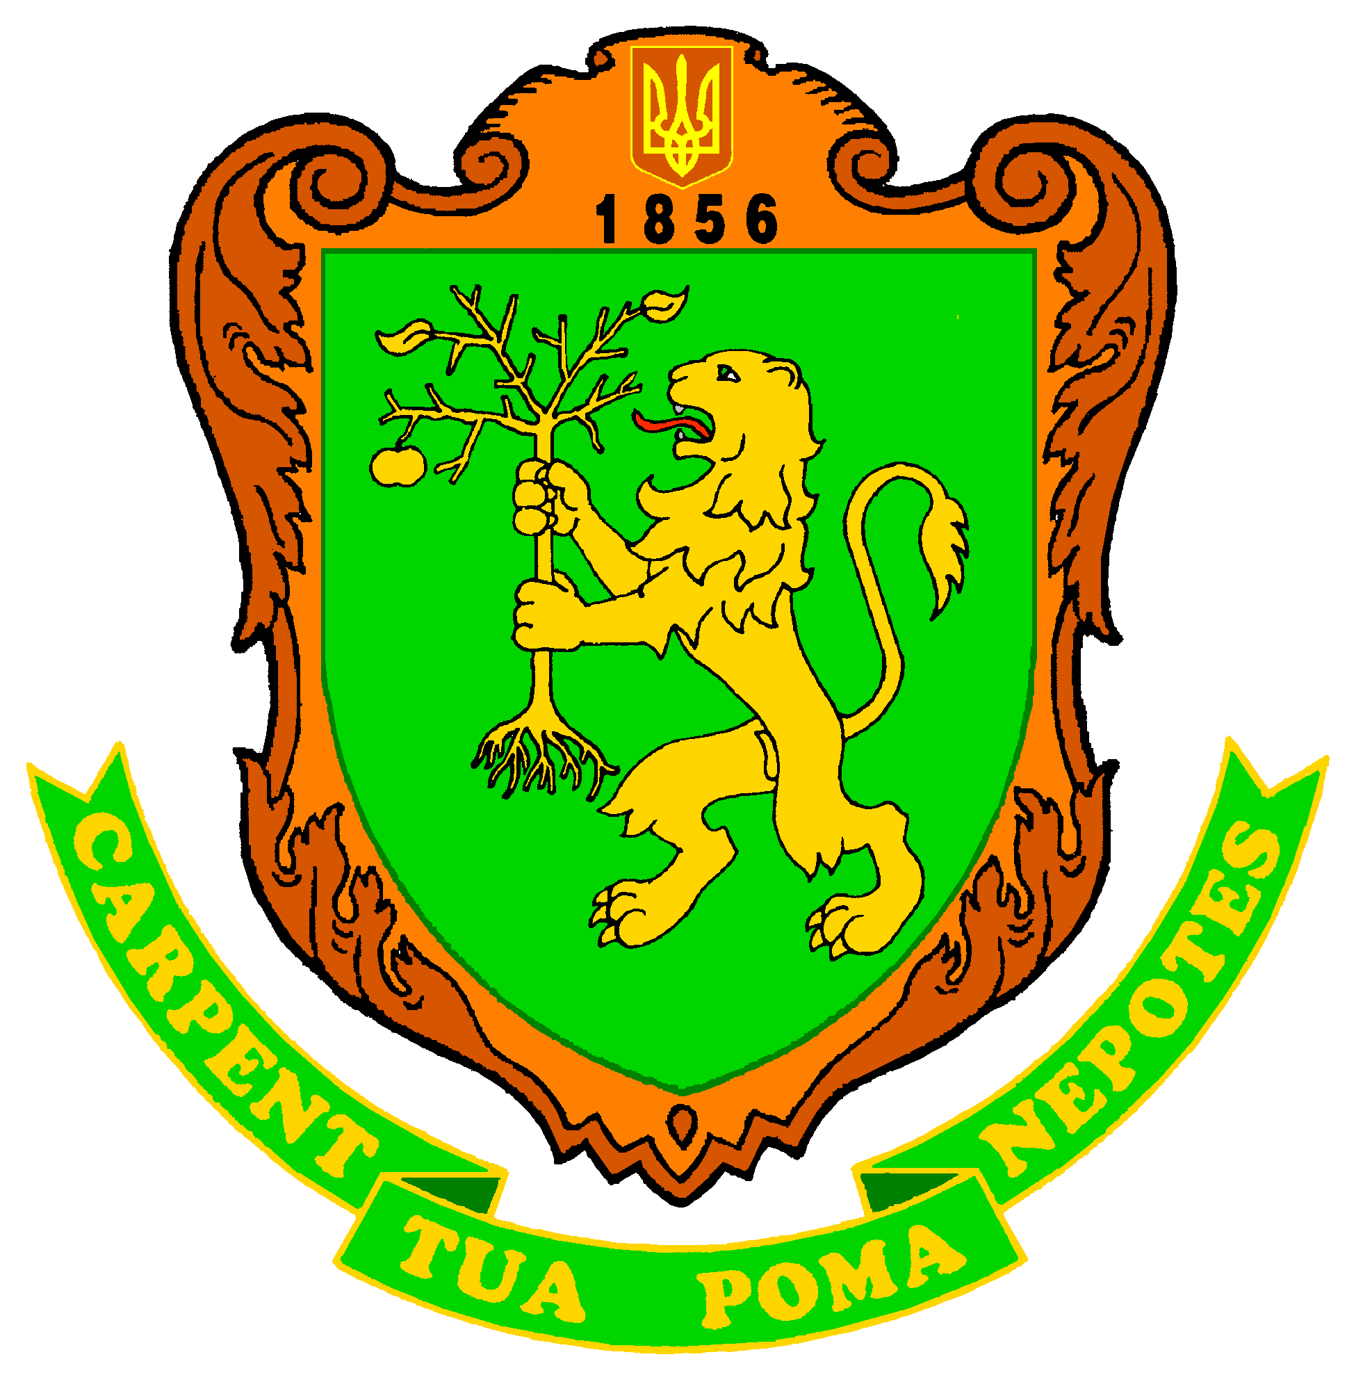
Міністерство освіти і науки України
Львівський НАЦІОНАЛЬНИЙ аграрний університет
80381, м. Дубляни, Жовківський р-н, Львівська обл.

MINISTRY OF EDUCATION AND SCIENCE OF UKRAINE
lviv NATIONAL agrarian university
Lviv-Dublyany, 80381, Ukraine

Invitation
Dear____________________________________________ !

Lviv National Agrarian University invites You to attend the
Xth International Scientific Conference
"Information technologies in energy and agro-industrial complex"
dedicated to the 165th anniversary of the University, 120th anniversary of conferring the status of the Academy, and the 20th anniversary of the Department of Power Engineering, which will be held at Lviv National Agrarian University on October 6-7, 2021

The following sections will be provided:
Section 1. Information technologies in energy systems, including renewable sources.
Section 2. Information technologies in energy efficiency, resource and energy saving.
Section 3. Information technologies in agro-industrial complex.
Section 4. Project management.
Section 5. Information technologies of economic and ecological assessment of projects and systems in energy and agro-industrial complex.

Conference works may be published in a specialized Collection of Scientific Works of Lviv NAU "Research of Agrarian Engineering", International Magazines "TEKA" and "Econtechmod". Requirements for the articles are defined on website of the University (http://lnau.edu.ua/lnau/index.php/uk/visnuk.html).
By decision of the editorial board, the best articles will be recommended for publication in the collections of scientific papers indexed in the Web of Sciences and Scopus science databases.

Address of Organizational Committee:
1 V.Velykoho Str., Lviv-Dubliany, 80381, Faculty of Mechanics and Power Engineering,
Dean, Prof, Stepan Kovalyshyn, tel.: +38 (032) 224-29-04, +38 (098) 479-54-80,
Head the Department of Power Engineering, Assistant Professor Serhii Syrotyuk,
tel.: +38 (032) 224-29-58, +38 (067) 939-62-46, e-mail: lnau_energetic@ukr.net, itea@lnau.edu.ua. Conference site:itea.lnau.edu.ua.

Respectfully,
Chief of Organizational Committee,
Rector of LNAU, Professor Volodymyr Snitynskyi

